
FOET & TBIIC

REPORT ON THE SKILLS-BASED PRACTICAL SHORT COURSES TRAINING PROGRAMME

NOVEMBER 2022 - APRIL 2023

BY
BAGOOLE CHRISTOPHER
Assistant Innovation officer

Table of Contents

Table of Contents 1
List of Figures 3
List of Tables 3
1 CHAPTER ONE: INTRODUCTION 4
1.1 Background 4
1.2 Overall Program Objectives 5
1.3 Content 5
1.4 Criteria for selection 6
2 CHAPTER TWO: DESCRIPTION OF ACTIVITIES PER SHORT COURSE 6
2.1 Certificate in Welding and metal part fabrication (CWM) 6
2.1.1 Knowledge Competency 7
2.1.2 Skill Competency 7
2.1.3 Areas of focus during the welding and metal part fabrication training 8
2.1.4 Metal fabrication assignments as a mode of assessment 8
2.1.5 List of students that successfully completed the training in CWM 10
2.1.6 List of students that did not complete the training in CWM 10
2.1.7 General Observation 10
2.2 Certificate in Post-harvest handling & processing technologies (CPP) 11
2.2.1 Overall program Objectives 11
2.2.2 Expected skills and competencies 11
2.2.3 Areas of focus during the Post-harvest handling & processing technologies training 12
2.2.4 Assignments as a mode of assessment in this section 13
2.2.5 List of students that successfully completed the training in CPP 15
2.2.6 General Observation 15
2.3 Certificate in brick laying and concrete practice (BCP) 15
2.3.1 Overall program Objectives 15
2.3.2 Knowledge Competency 15
2.3.3 Skill Competency 16
2.3.4 Areas of focus during the brick laying and concrete practice training 17
2.3.5 BCP Assignments as a mode of assessment 17
2.3.6 List of students that successfully completed the training in BCP 19
2.3.7 General Observation for BCP 19
2.4 Certificate in Irrigation technologies and Innovations (CIT) 20
2.4.1 Overall program Objectives 20
2.4.2 Skill and Knowledge Competency 20
2.4.3 Areas of focus during the Irrigation technologies and Innovations training 20
2.4.4 CIT Assignments as a mode of assessment 21
2.4.5 List of students that successfully completed the training in CIT 24
2.4.6 List of students that did not complete the training in CIT 24
2.4.7 General Observation for CIT 24
2.5 Certificate in Automotive Repair, Operation and Maintenance (CAM) 24
2.5.1 Overall program Objectives 24
2.5.2 Knowledge Competency 25
2.5.3 Areas of focus during the Irrigation technologies and Innovations training 25
2.5.4 CAM Assignments as a mode of assessment 26
2.5.5 List of students that successfully completed the training in CAM 27
2.5.6 List of student(s) that did not complete the training in CAM 28
2.5.7 General Observation for CAM 28
2.6 Overall enrolment and completion Summary 29
3 CHAPTER THREE: CHALLENGE(S) AND CONCLUSIONS 30
3.1 Challenge(s) 30
3.2 Conclusion 30

List of Figures
Figure 1: Some of the illustrations during the training of CWM 9
Figure 2: Illustrations during the training of CPP 14
Figure 3: Concrete works and Products 18
Figure 4: Construction works 18
Figure 5: CIT Training Proceedings 23
Figure 6: Trainees being introduced to Tractor Driving 26
Figure 7: Students overhauling the Engine 27

List of Tables

Table 1: List of students that successfully completed the training in CWM 10
Table 2: List of students that did not complete the training in CWM 10
Table 3: Students that successfully completed the training in CPP 15
Table 4: Students that successfully completed the training in BCP 19
Table 5: Students that successfully completed the training in CIT 24
Table 6: Students that did complete the training in CIT 24
Table 8: Students that successfully completed the training in CAM 27
Table 9: Students that did not complete the training in CAM 28

CHAPTER ONE: INTRODUCTION

Background
The Ugandan economy is progressively growing at staggered rates ranging between 5 and 7% and largely driven by agriculture, manufacturing and the expansion of the service sector. The forward, intermediary, and backward linkage operations in all these sectors require highly trained and skilled personnel to provide the required services. With the population increasing at an annual rate of 3.2%, there have been growing challenges of unemployment, food shortage, housing, and calls for improved infrastructure for private and public service. These challenges call for robust mitigation approaches, one of which is equipping the human resource with the required set of skills to spur innovations for self-employment and general service industry support.
The Busitema University through the Faculty of Engineering & Technology, and its Technology Business and innovations incubation center (TBIIC) established an opportunity for Skills Development Program (SDP) on short term basis of 6 months to equip mainly the youth with the requisite technical skills that are badly needed in the service and manufacturing industries. The areas of focus for this short term training program include welding and metal part fabrication, Post-harvest handling & processing technologies, Irrigation technologies & Innovations, Automotive repair, operation & Maintenance and brick laying and concrete practice. These programs target producing highly trained and skilled human resource urgently needed in the wide range of industries.
The program content for each of the five (5) short-term courses is tailored to the hands-on training to fill skills gap that many employers decry of the many school graduates and dropouts, whom they find unemployable but rather require further polishing to meet employment requirements. Also professionals from relevant backgrounds are always given a chance to renew their skills and knowledge profiles for better performance in their fields of work.
This skilling programme started in November 2022 with a population of 73 trainees (61 males and 12 females), and ended in April, 2023, the main sponsor being Stanbic Bank. In general the training started with orientation of the students to create awareness about personal safety, the course outline and expected outcome per short course. This orientation exercise lasted for two weeks.
All the teaching and learning schedules (course outline and time tables) for the respective courses were effectively made and followed by the instructors of the respective short course programmes

Overall Program Objectives
- To be a center of excellence in vocational training.
- Assist in human resources development by providing precise and assessed skilled manpower quantitatively as well as qualitatively.
- Create an incentive and desire for youth to attain a high level of knowledge and skills competency in art and craft.
- Provide technical and vocational training basis which reflects the requirements of industry.

Content
Curricula/course content for the five (5) skills based short practical short courses (of 6 months) were developed and approved by the university council in May, 2020.

Criteria for selection
- Merit based selection, considering both male and female students. Females and people with disabilities were highly encouraged to apply.
- At least 11 candidates were selected from each of the six districts where Busitema University campuses are located
- Holders of UCE Certificate
- Slots for holders of PLE Slip, and professionals from relevant backgrounds were available on self-sponsorship.

CHAPTER TWO: DESCRIPTION OF ACTIVITIES PER SHORT COURSE
Generally, the teaching and learning was successfully conducted for each of five short courses, majorly being dominated with hands on and less of the theory. These include: - welding and metal part fabrication (CWM), Post-harvest handling & processing technologies (CPP), irrigation technologies & Innovations (CIT), automotive repair, operation & Maintenance (CAM) and brick laying and concrete practice (BCP).

Certificate in Welding and metal part fabrication (CWM)
The program target was to produce technicians with hands-on skills and capable of undertaking the following:

Knowledge Competency
After successful completion of this training, the trainee should be able to:
- Describe Measuring, Marking, Cutting, Sawing, and Filing, Drilling/Counter sinking, Threading tools / instruments, their uses & Safety and Personal safety.
- Explain basic arithmetic & geometric terminologies, simple estimation of fabrication materials
- Explain the Gas Welding / Cutting tools and equipment, their use and safety.
- Determine Arc Welding processes, tools and equipment, their use and safety.
- Express the suitable welding joints, welding positions, Electrodes, their use and selection.
- Describe welding defects and their remedies.
- Explain the inspection and testing of welded joints to ensure quality of weld.

Skill Competency
After successful completion of this training, the trainee should be able to:
- Measure, mark, cut, saw, file, grind, drill (countersink, counterbore), and thread tapping.
- Weld with gas welding process on different joints and positions
- Solder the sheet, pipe and solid metals
- Braze the common metals i.e. Mild steel (MS) Cast iron (CI), Stainless steel (SS), and copper (Cu).
- Weld with Arc welding process on different joints and positions
- Weld simple structural shapes

Areas of focus during the welding and metal part fabrication training
The following fundamental areas in Welding were considered in the training and skilling of the learners.
Introduction, welding and general shop safety, Welding workshop setup, Basic weld joints and positions, Out of Position Welding Techniques, Measuring and cutting materials, Oxyfuel Welding and Oxyacetalene cutting, safety requirements for oxy-fuel processes, Shielded metal arc welding process, Hand Tools, Usage and maintenance, Power tools, Bench shop practice, Simple Workshop Practices/Tools/Equipment maintenance, Welding Defects, Metal fabrication Safety practices, Identification and Interpretation of simple drawings, Mig welding Equipment, Tig welding Equipment, Metal Identification, Metal weldability, Welding Electrodes, SMAW of cast iron, Steel pipe welding, Fabrication works, Welding of Thick metal parts (8mm and above), Distortions in welding, Preparations and fabrication of metallic doors/Windows &chairs, General machinery and Automobile welding repair Techniques, Basic set-up configurations of various welding equipment, Metal fabrication assignments (Individual tasks identification), Metal fabrication assignments (Identification of faults and corrections), Module wrap up, Seminar on module and Assessment

Metal fabrication assignments as a mode of assessment
The welding and metal part fabrication group was divided into two groups, of which one worked on the fabrication of the window while the other worked on the door. The figures below illustrate part of the different activities that the trainers and trainees did.

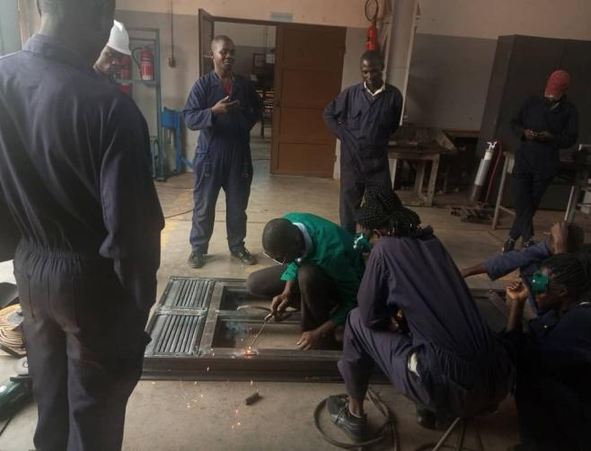
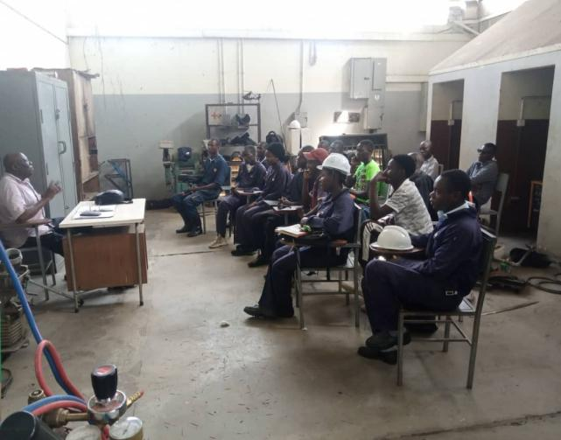

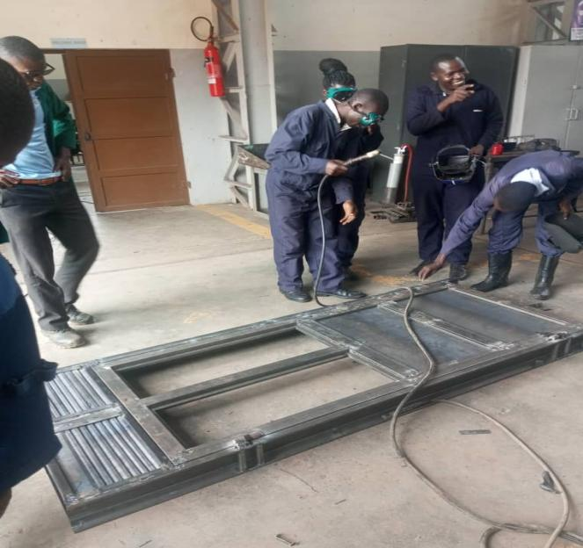
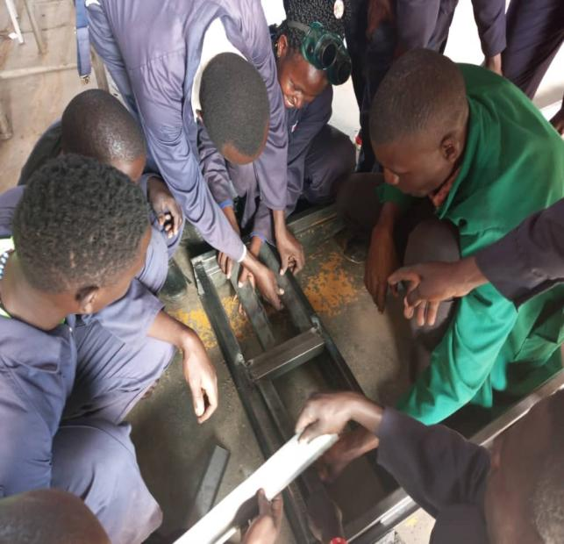

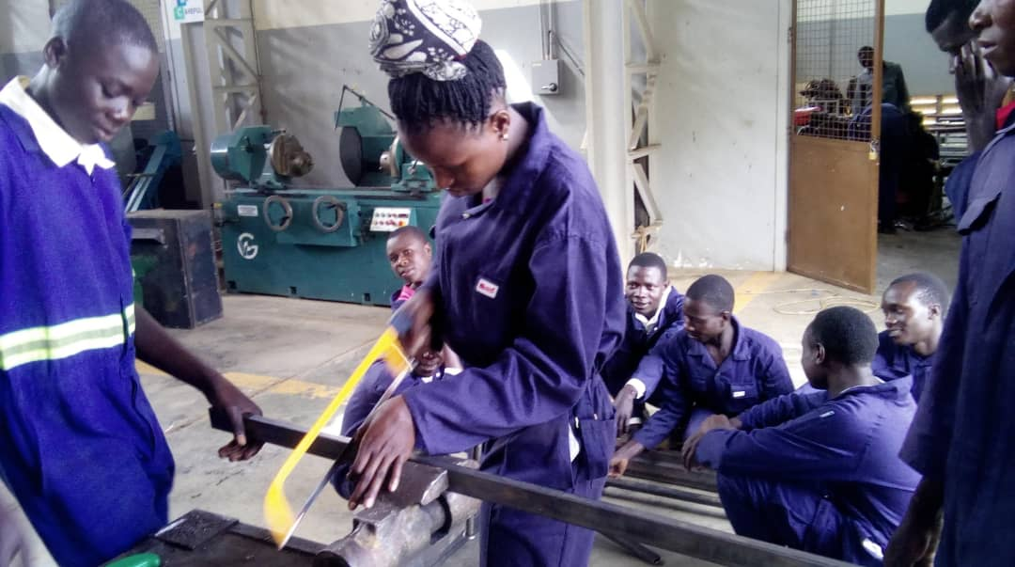
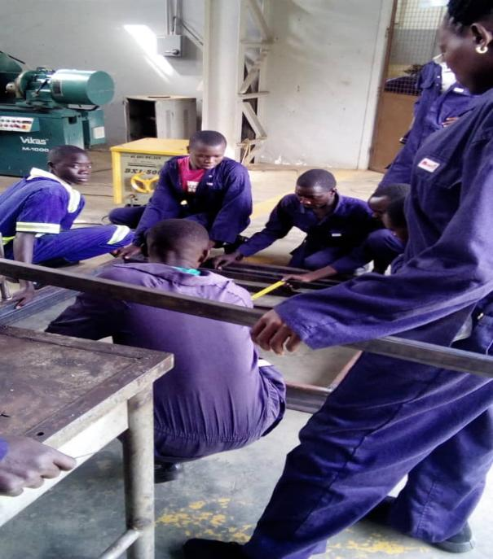
Figure 1: Some of the illustrations during the training of CWM

List of students that successfully completed the training in CWM
Table 1: List of students that successfully completed the training in CWM
S/N | Name | Gender | Sponsor | District | Certificate Serial Number
1 | Abbo Mary | F | STANBIC | TORORO | BU/CWM/001
2 | Atabong Mary Gorret | F | STANBIC | TORORO | BU/CWM/002
3 | Awolo Denis Cyrus | M | STANBIC | TORORO | BU/CWM/003
4 | Echakara Emmanuel | M | STANBIC | TORORO | BU/CWM/004
5 | Mangeni Francis | M | STANBIC | BUSIA | BU/CWM/005
6 | Oboth Noah Felix | M | STANBIC | TORORO | BU/CWM/006
7 | Odisi Felex | M | STANBIC | TORORO | BU/CWM/007
8 | Okello Thomas | M | STANBIC | SOROTI | BU/CWM/008
9 | Oketch Sebastian | M | STANBIC | TORORO | BU/CWM/009
10 | Okoth Dominic | M | STANBIC | TORORO | BU/CWM/010
11 | Okuku Silvester | M | STANBIC | BUSIA | BU/CWM/011
12 | Okwi Walter Sam | M | STANBIC | MBALE | BU/CWM/012
13 | Ongwen Yakobo | M | STANBIC | TORORO | BU/CWM/013
14 | Opedun Robert | M | STANBIC | PALLISA | BU/CWM/014
15 | Osillo Moses | M | STANBIC | TORORO | BU/CWM/015
16 | Oundo Clement | M | STANBIC | BUSIA | BU/CWM/016
17 | Wafula Stephen | M | STANBIC | BUSIA | BU/CWM/017
18 | Wanyama Stephen | M | STANBIC | BUSIA | BU/CWM/018
19 | Zabu Sande Labu | M | STANBIC | MBALE | BU/CWM/019

List of students that did not complete the training in CWM
Table 2: List of students that did not complete the training in CWM
S/N | Name | Gender | Sponsor | District | No Certificate Awarded
1 | Bebacha Nesta | M | STANBIC | BUSIA
2 | Magambo Silver | M | STANBIC | PALLISA
3 | Oketcho Wilbroad | M | STANBIC | TORORO
4 | Omijo Mathew | M | STANBIC | TORORO

General Observation
- Out of the 23 students that pursued this course, of which 21 are males and 2 are females, 19 successfully completed the training while 4 did not.
- All the 23 students that trained were Sponsored by Stanbic

Certificate in Post-harvest handling & processing technologies (CPP)

Overall program Objectives
- To produce highly skilled personals in the Agricultural Post-harvest handling and processing technologies.
- To be a center of excellence in post-harvest handling and processing technologies training.
- To assist in human resources development by providing precise and assessed skilled manpower quantitatively as well as qualitatively.
- To create an incentive and desire for workers to attain a high level of knowledge and skills competency in post-harvest handling and processing.
- To provide technical and vocational training basis which reflects the requirements of industry.

Expected skills and competencies
The program target is to produce technicians with hands-on skills and capable of undertaking the following:
- Have a clear understanding of “postharvest” as a value-chain system, effectively combat postharvest losses in crops and other biological products through better handling, processing and storage.
- Clearly understand the role of cleaning, packing, processing, storage, transportation and distribution in Post-harvest handling.
- Know the simple design, material requirements and operation principles of postharvest technologies (both traditional and modern)
- Have demonstrable hands-on skills on agricultural post-harvest processes and technologies with an appreciation of indigenous knowledge.
- Appreciate effective communication skills, gender, socio-economic and environmental protection issues in implementation of the post-harvest handling and processing technologies.

Areas of focus during the Post-harvest handling & processing technologies training
The following fundamental areas in Post-harvest handling & processing were considered in the training and skilling of the learners.
Introduction, general personal and workshop safety, fruit vegetable harvesting and handling, fruit packaging, transport and marketing processes, simple practical lessons about fruit maturity indices of various fruits that included among others climacteric and non-climacteric fruits, drying methods of various crops like direct sun drying of cassava, Shade drying plus making several observations on the product, Construction of a farm based drying shade with three drying pallets plus its operation its operation mechanism, drying air conditions, relative humidity, temperature, construction of an indoor based storage silo of capacity 500kg, comparison of samples subjected to different conditions, Practicals on fruit and vegetable preservation were done with much focus put on fruit preservation and value addition, different preservations like shade drying of fruits and solar drying and also computer skills.

Assignments as a mode of assessment in this section
The Post-harvest handling & processing technologies group worked as a single group in the execution of several assignments as justified by the above mentioned, and the figures presented below.
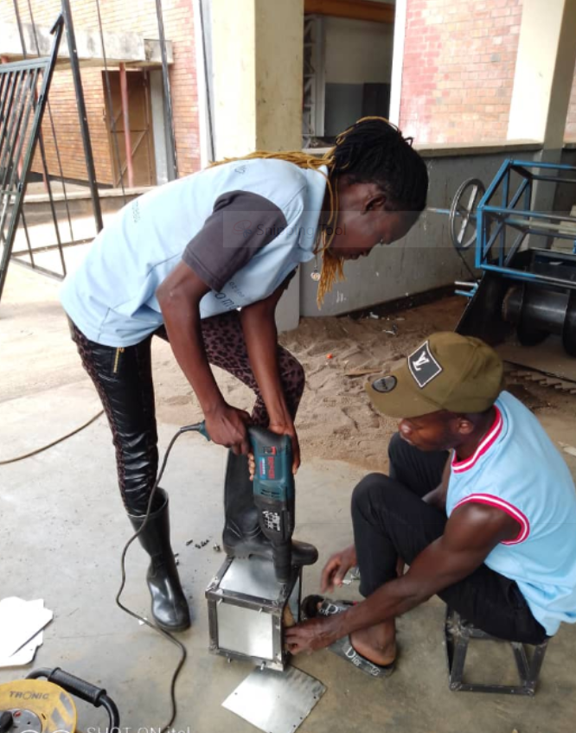
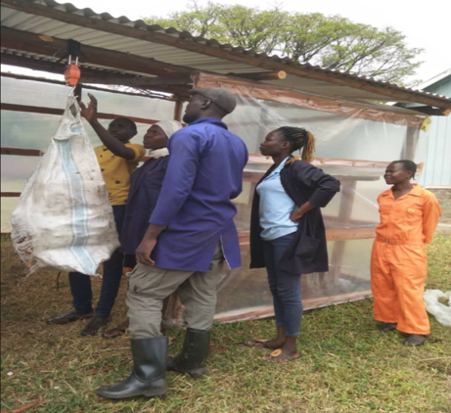

Students fabricating a hopper for the silo

Weighing of cassava upon reception from the garden

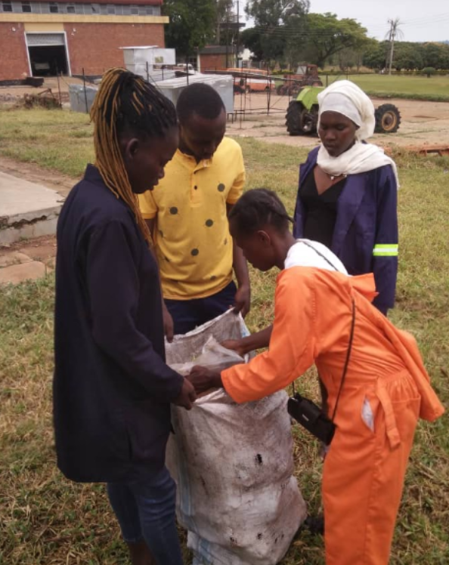
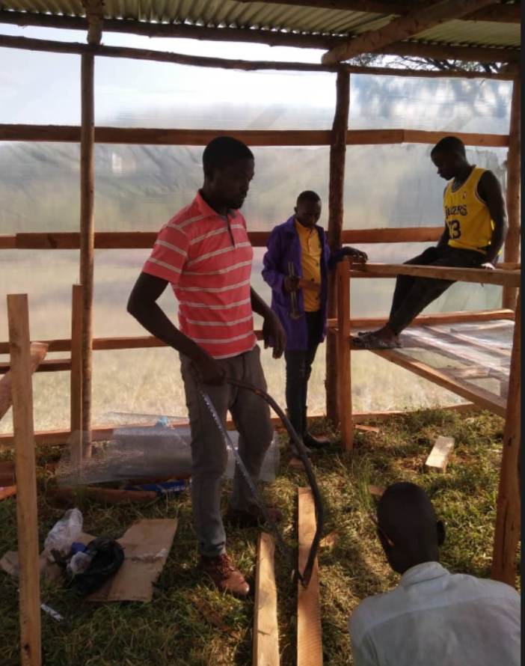

Students constructing a drying shade

Cassava reception and inspection at the drying shade

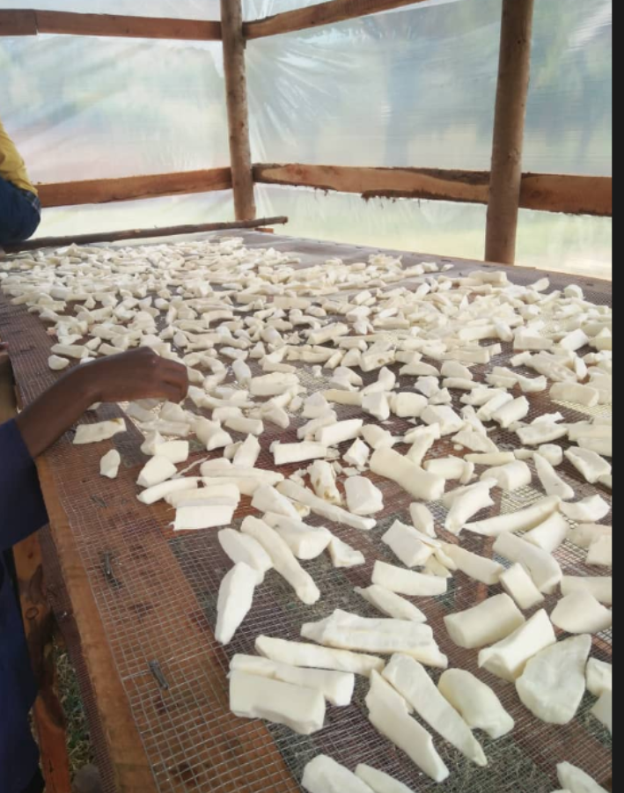
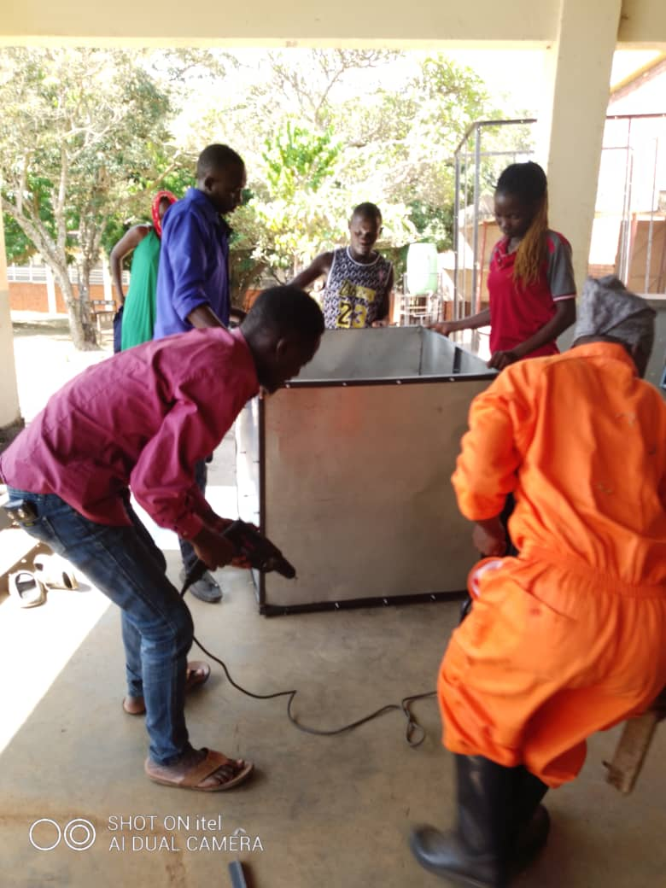

Cassava slices being dried under the drying shade

Students constructing a storage silo

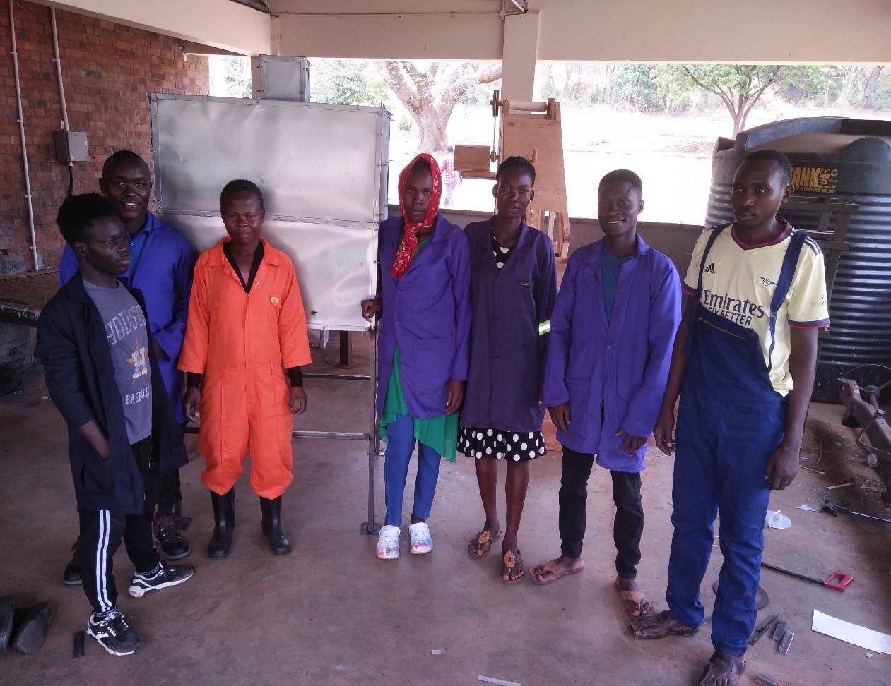
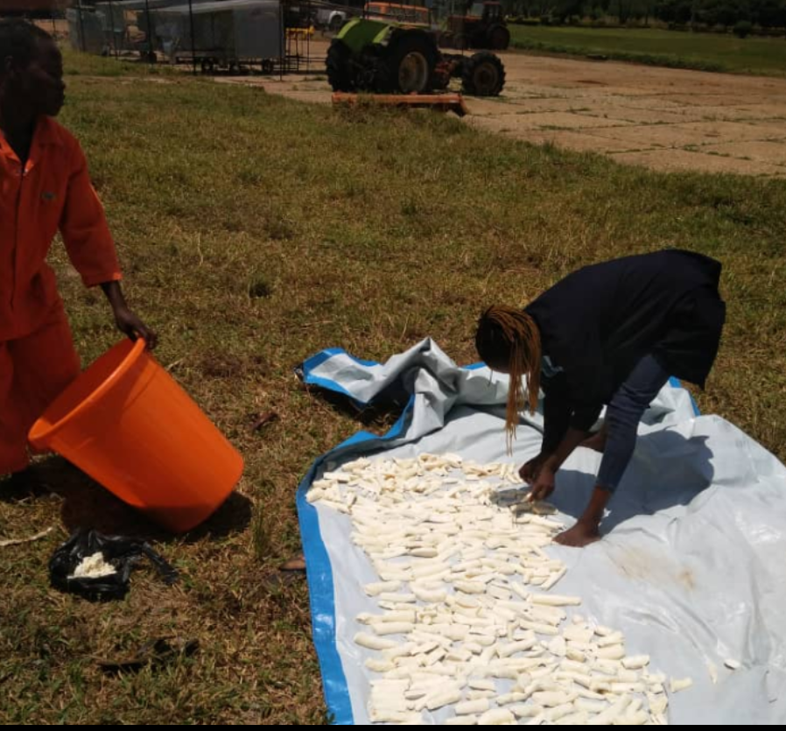

Figure 2: Illustrations during the training of CPP

Students posing for a photo at the silo they made

Sun drying of cassava

List of students that successfully completed the training in CPP
Table 3: Students that successfully completed the training in CPP
S/N | Name | Gender | Sponsor | District | Certificate Serial Number
1 | Achieng Beatrice | F | STANBIC | TORORO | BU/CPP/001
2 | Apio sarah | F | STANBIC | SOROTI | BU/CPP/002
3 | Gaigulo Ambrose | M | STANBIC | KAMULI | BU/CPP/003
4 | Kabagambe Ezra | M | SELF | KIRUHURA | BU/CPP/004
5 | Mirembe susan | F | STANBIC | BUSIA | BU/CPP/005
6 | Simon peter Olobo | M | STANBIC | SOROTI | BU/CPP/006

General Observation
- All the 6 students that pursued this course, of which 3 are males and 3 are females, successfully completed the training.
- Only one was on private

Certificate in brick laying and concrete practice (BCP)

Overall program Objectives
- Assist in human resources development by providing precise and assessed skilled manpower quantitatively as well as qualitatively.
- Create an incentive and desire for workers to attain a high level of knowledge and skills competency in brick laying and concrete practice.
- Provide technical and vocational training which reflects the requirements of the civil works

Knowledge Competency
After successful completion of this training, the trainee should be able to:

- Come up with different kind of quality molds i.e., blocks (both solid and hollow), pavers, culverts, curbs, slabs, spindles, fencing poles, ventilators being mindful of Safety and Personal safety.
- Know materials used when making the above products
- Explain basic arithmetic & geometric terminologies in relation to all kinds of molds
- Describe the molding tools and equipment, their use and safety as well.
- Explain and demonstrate the curing process, and its relevance.
- Select the right tool, Equipment and material applicable to the right product or mold of interest.
- Describe molding defects and their remedies.
- Explain the inspection and testing of molds to ensure quality.

Skill Competency
After successful completion of this training, the trainee should be able to:
- Prepare concrete and mortar to generate products such as pavers, blocks, culverts, slabs, ventilators etc.
- Practice safety precautions, rules and regulations required in the building industry
- Fix and lay the above-mentioned products.
- Know the types, care and uses of tools required.
- Know material, their care, storage and their uses for any required product

Areas of focus during the brick laying and concrete practice training
The following fundamental areas in brick laying and concrete practice were considered in the training and skilling of the learners.
Introduction, general site procedures and safety at the construction site, different concrete mix ratios and how to mix them, different brick laying patterns, Setting out a structure dominated by measurements and interpretation of a simple plan, fundamentals of making a plan for the house, Construction from the foundation to beam level (Using the pre-cast slabs), making pavers, facing poles, pre-cast slabs, curbs, laying the pavers, concrete slabs and construction of the structure using concrete slabs, installation of fencing poles and general fencing.

BCP Assignments as a mode of assessment
The Brick laying and concrete practice group worked as a single group in the execution of several assignments as justified by the above mentioned, and the figures presented below
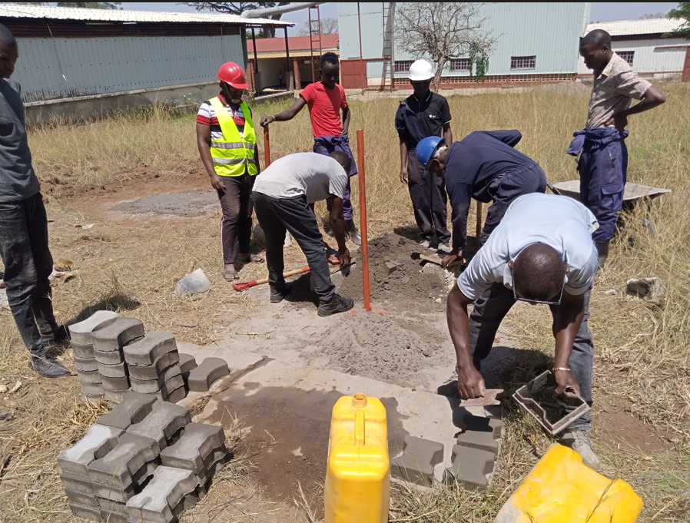
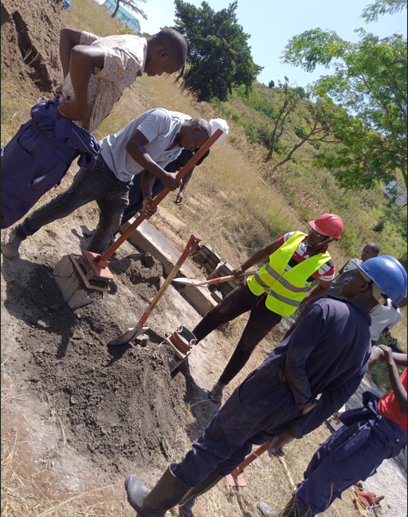

Figure 3: Concrete works and Products
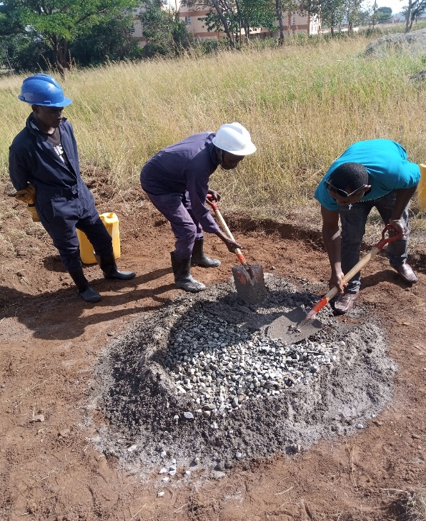
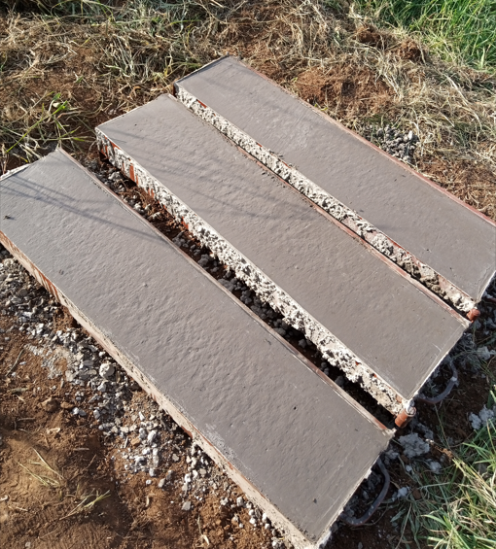
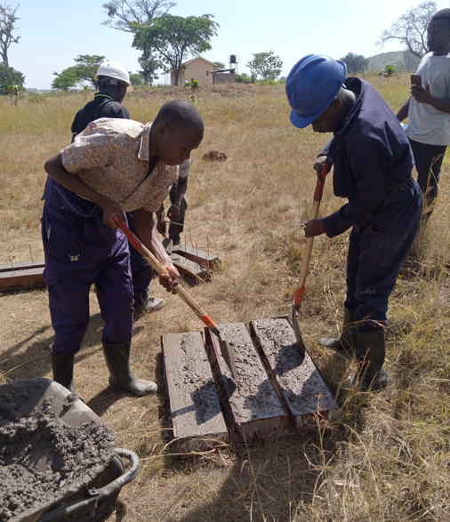
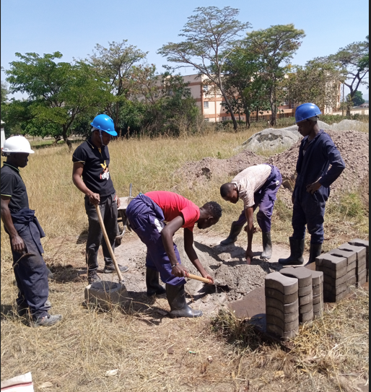

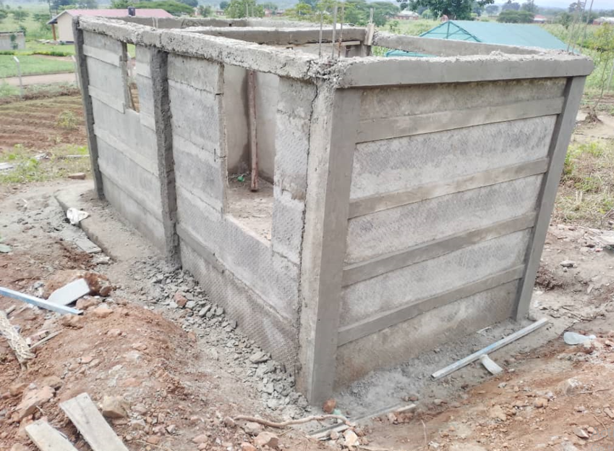
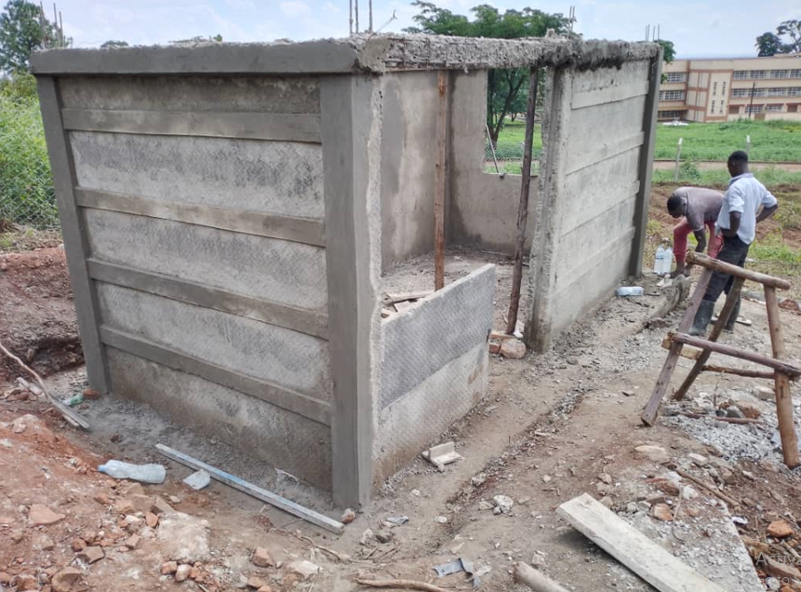
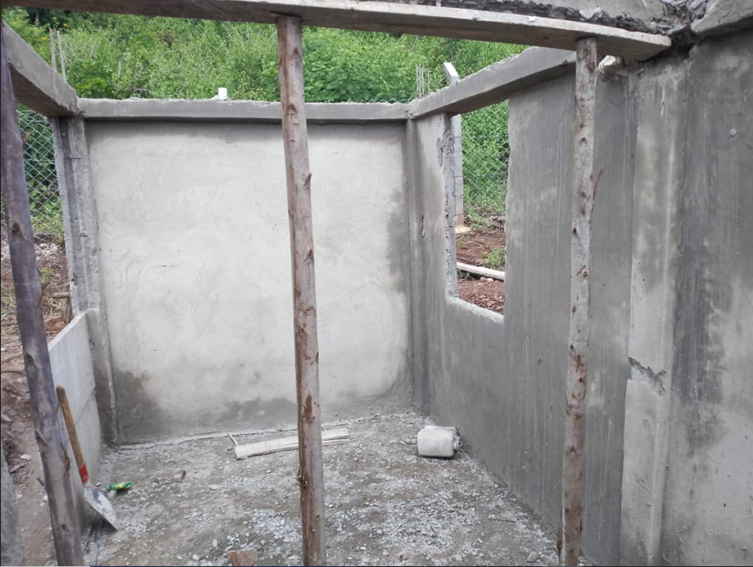

Figure 4: Construction works

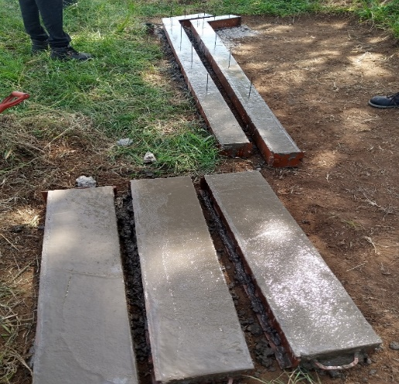
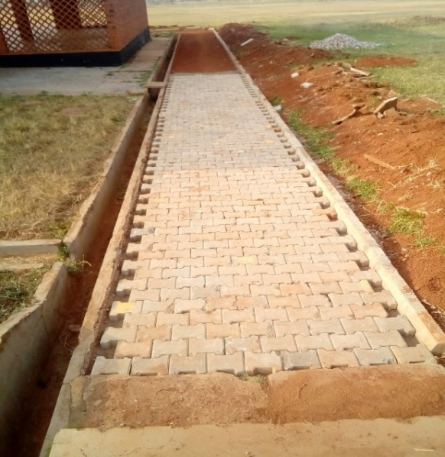
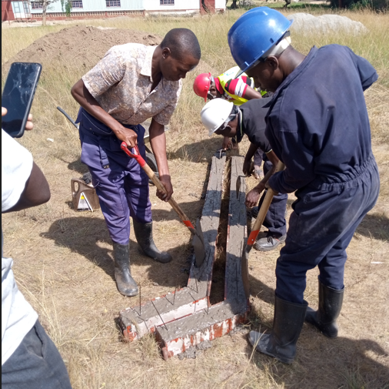

List of students that successfully completed the training in BCP
Table 4: Students that successfully completed the training in BCP
Name | Gender | Sponsor | District | Certificate Serial Number
Asianut Phillip | M | STANBIC | TORORO | BU/BCP/001
Bwire Borniface | M | STANBIC | BUSIA | BU/BCP/002
Mangeni Evans Afry | M | STANBIC | BUSIA | BU/BCP/003

General Observation for BCP
- All the 3 students that pursued this course successfully completed the training.

Certificate in Irrigation technologies and Innovations (CIT)

Overall program Objectives
- Acquire practical knowledge and hands-on skills of designing, installing, and managing farm irrigation systems
- Develop a systems thinking on appropriate irrigation-based innovations geared on enhancing Food security

Skill and Knowledge Competency
- A trainee will acquire practical knowledge and hands-on skills pertaining Irrigation system Design and Management
- A trainee will participate in the simple design, installation and management of appropriate Irrigation technologies

Areas of focus during the Irrigation technologies and Innovations training
Safety in the field and regulations including PPEs, pump identification, pump operation and maintenance, Identification of fittings used in drip irrigation system, connection of a simple drip irrigation system, Plumbing and Pipe Fitting, Component assembly of a Sprinkler Irrigation demonstration, fittings used in the sprinkler irrigation system, Simple demonstration for sprinkler irrigation system, field survey using GPS, Calculating the area of a given field or plot (establishing dimensions), Conversion of units of length, area and volume, Entrepreneurship and small scale business establishment, Common soil tests such as Infiltration rate, Soil texture test, Planning of the garden, making of ridges, plots and trenching, Soil Quality Assessment, identification of different soil types with their suitable crops, Organic and Inorganic fertilizers, Nursery bed preparation, soaking of seeds, Planting of seeds and watering, availability, choice of water source, Choice of the equipment, with their specifications, comparing the different designs and choosing the best, positioning of sprinklers, Monitoring of the drip irrigation systems
In summary, the following fundamentals of Irrigation were considered in undertaking the skilling of the learners: - Field survey and planning, Field capacity estimation, System capacity, Preliminary design, Bill of Quantities, Actual system design, Installation

CIT Assignments as a mode of assessment
The Irrigation technologies and innovations group worked as a single group in the execution of several assignments as justified by the above mentioned, and the figures presented below
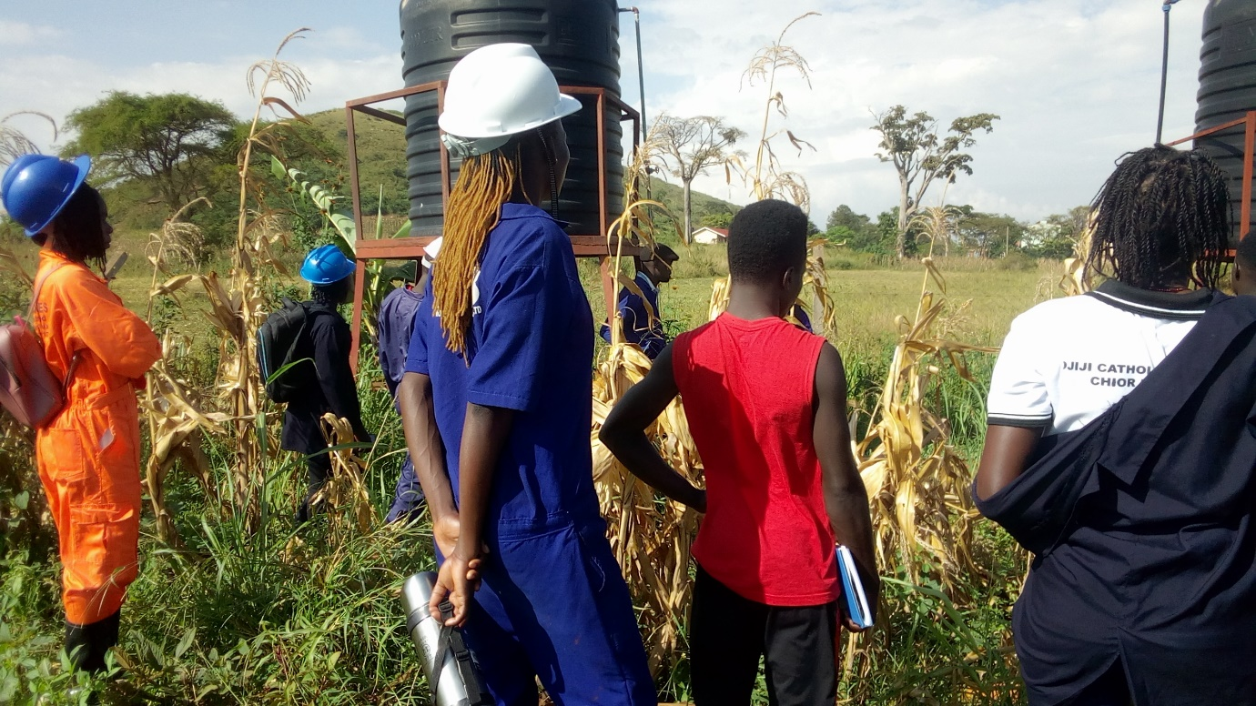
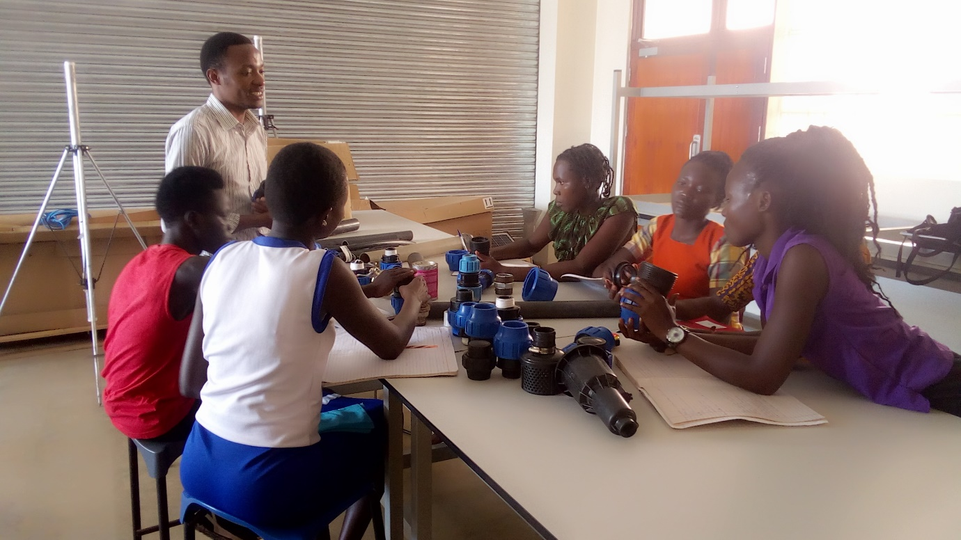

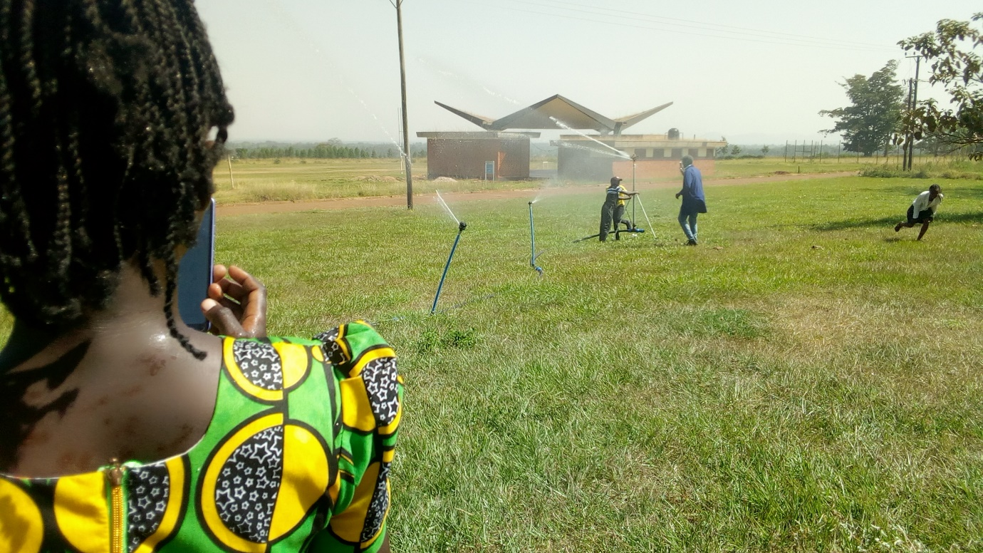
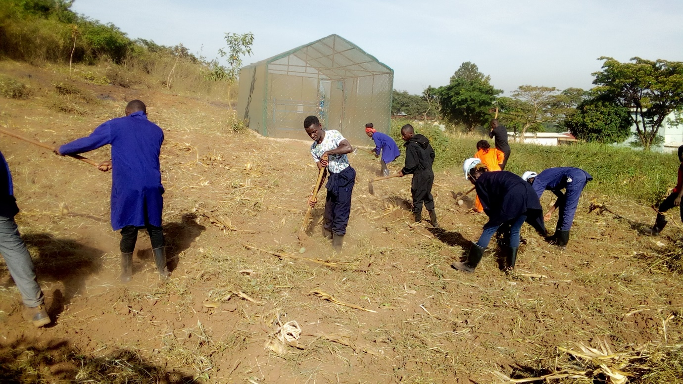

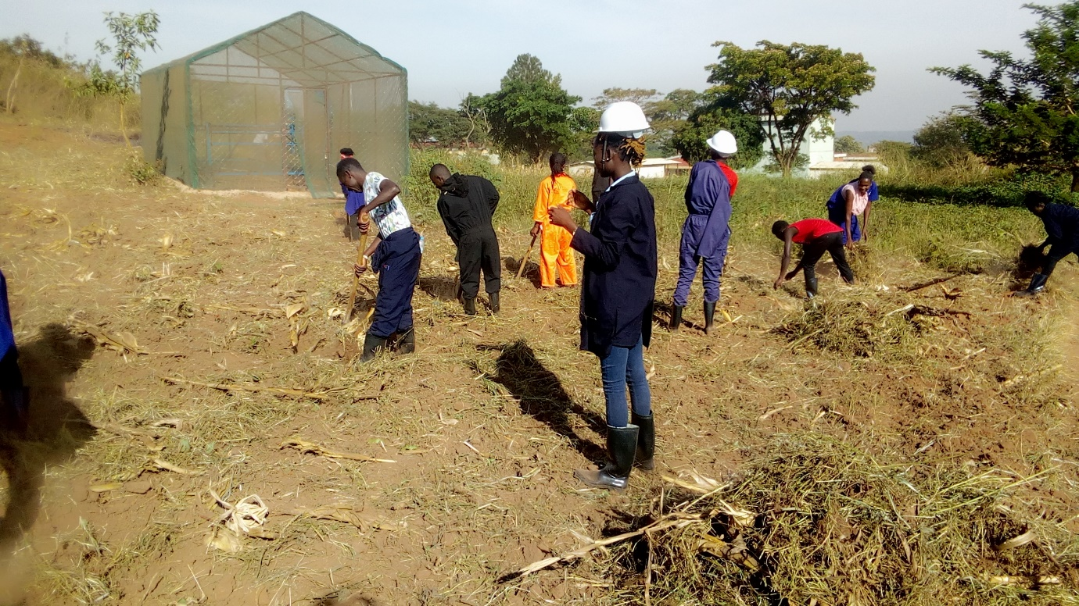
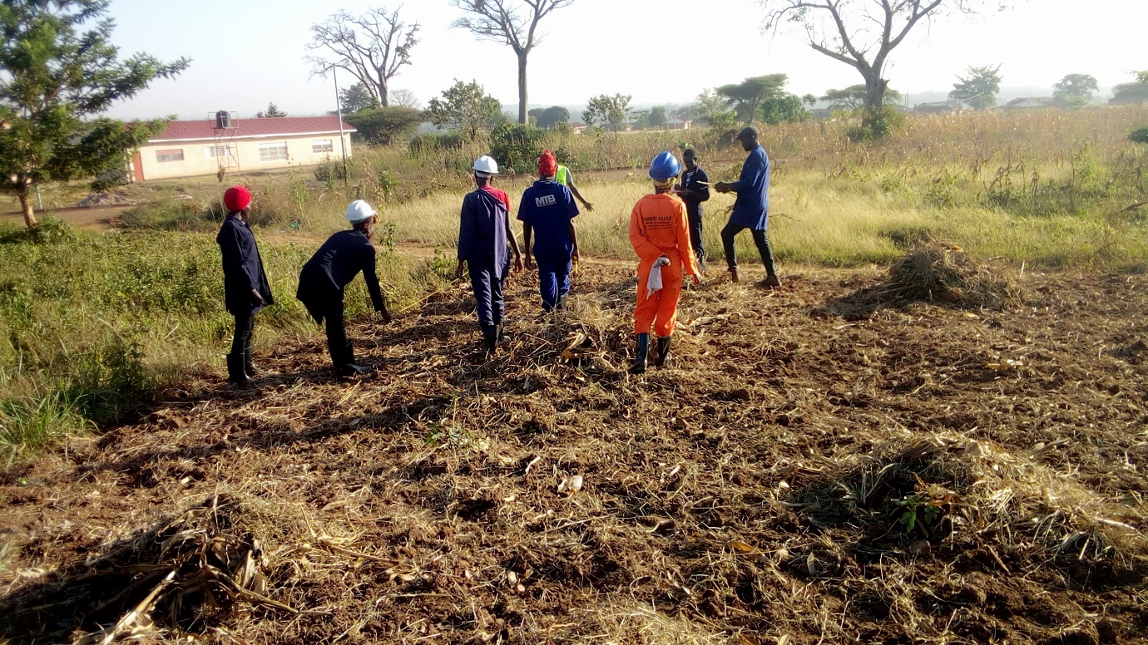

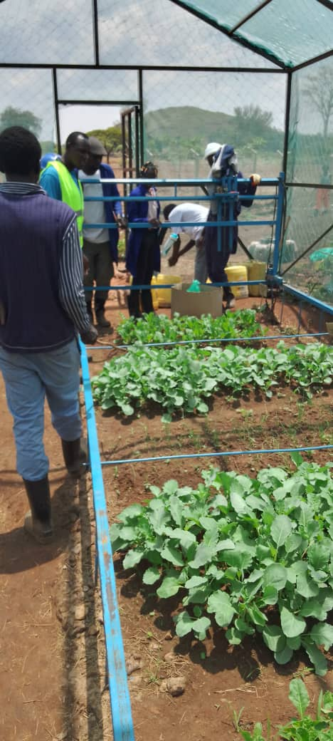
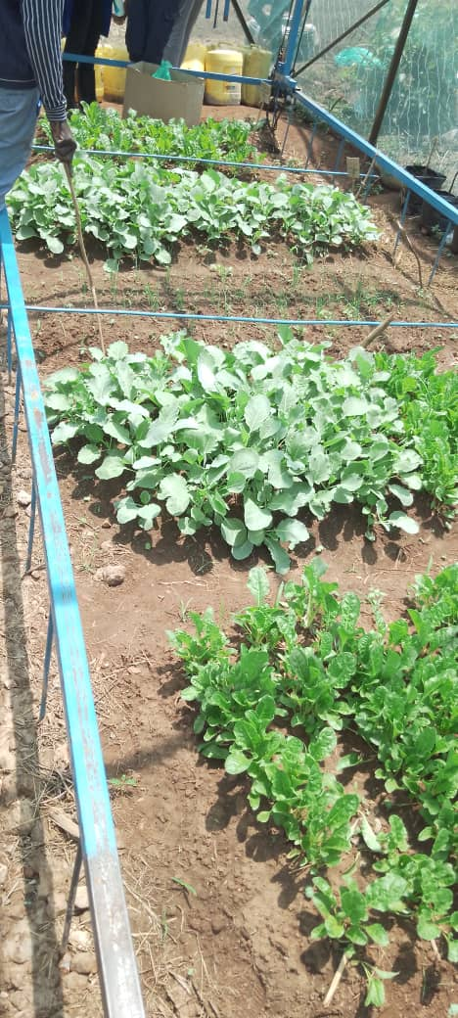

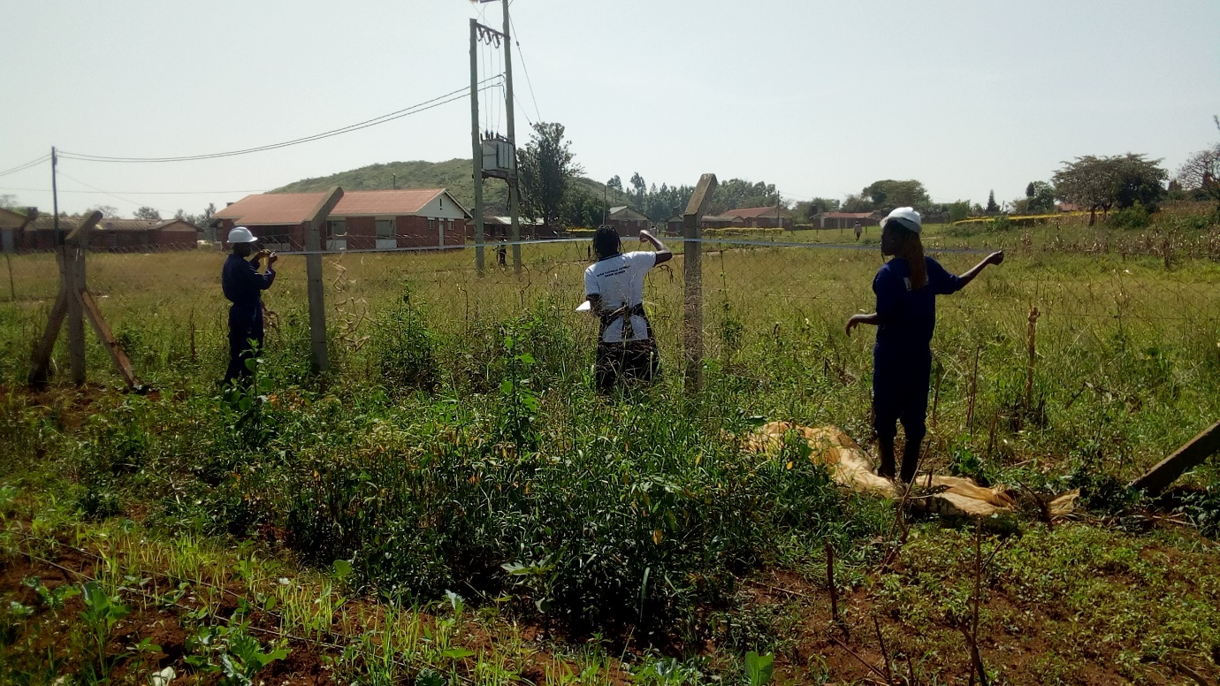
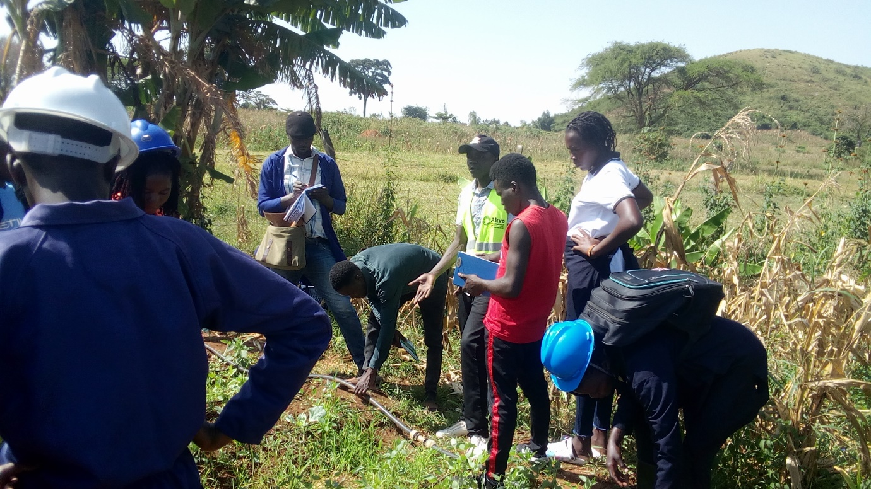

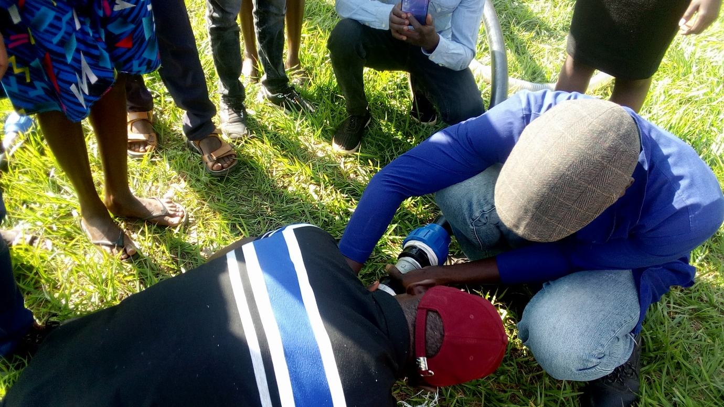

Figure 5: CIT Training Proceedings

List of students that successfully completed the training in CIT
Table 5: Students that successfully completed the training in CIT
S/N | Name | Gender | Sponsor | District | Certificate Serial Number
1 | Arwao Caroline | F | STANBIC | SOROTI | BU/CIT/001
2 | Athieno faith | F | STANBIC | TORORO | BU/CIT/002
3 | Awor everline | F | STANBIC | TORORO | BU/CIT/003
4 | Bwire paul | M | STANBIC | BUSIA | BU/CIT/004
5 | Esangalo Alex | M | STANBIC | TORORO | BU/CIT/005
6 | Mbweka Violet | F | STANBIC | BUSIA | BU/CIT/006
7 | Mugerwa James | M | STANBIC | KAMULI | BU/CIT/007
8 | Mukhama Emmanuel | M | STANBIC | MBALE | BU/CIT/008
9 | Opolot Ben | M | STANBIC | SOROTI | BU/CIT/009
10 | Tumwine Gilbert | M | STANBIC | KAMULI | BU/CIT/010

List of students that did not complete the training in CIT
Table 6: Students that did complete the training in CIT
S/N | Name | Gender | Status | District | No Certificate Awarded
1 | Odiit pascal | M | STANBIC | BUSIA
2 | Were Asuman | M | STANBIC | MBALE

General Observation for CIT
- Out of 12 students that pursued this course, of which 8 are males and 4 are females, 10 successfully completed the training while only 2 were unsuccessful

Certificate in Automotive Repair, Operation and Maintenance (CAM)

Overall program Objectives
Acquire practical knowledge and hands-on skills of repairing, servicing/maintaining and managing automotive machinery

Knowledge Competency
A trainee will acquire practical knowledge and hands-on skills pertaining operation, repair, maintenance/service, and management of automobiles.

Areas of focus during the Irrigation technologies and Innovations training
workshop Safety, rules and regulations, Use of PPE, tools and Equipment used in automobile repair and maintenance section, Vehicle terminology, vehicle history and chassis, vehicle layout, and vehicle body components, Introduction to automobile systems, maintenance and service, Introduction to engine technology, routine maintenance and service of engine, Engine overhaul, identifying parts, engine timing, faults and troubleshooting, service and maintenance, Transmission system (manual and automatic) principle of operation, faults, trouble shooting, fuel supply system , lubrication, suspension, steering, hydraulic, electrical /starting, braking, exhaust, cooling, General maintenance and service of an automobile, traffic rules and regulations, introduction to road signs, Introduction to tractors, tractor controls and driving, operation, service and maintenance
The following fundamental automobile system areas were considered in the undertaking of skilling the learners: - engine (power system), transmission system, cooling system, lubrication system, starting system, suspension system, steering system, service and vehicle maintenance, driving and tractor operation.

CAM Assignments as a mode of assessment
The Automotive repair, Operation and Maintenance group worked in a series of groups in the execution of several assignments as justified by the above mentioned, and the figures presented below:-
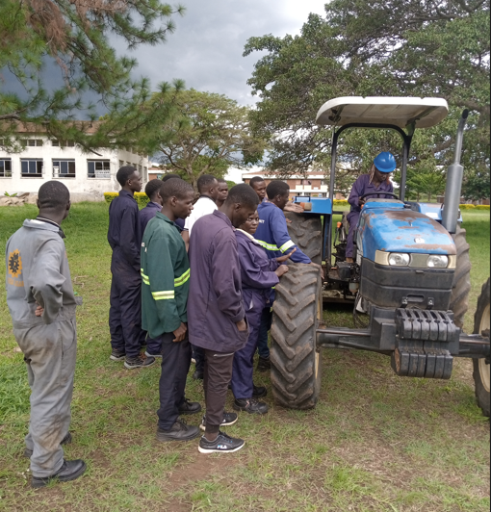
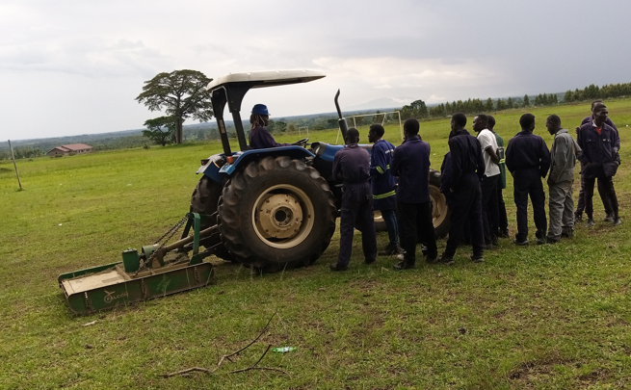

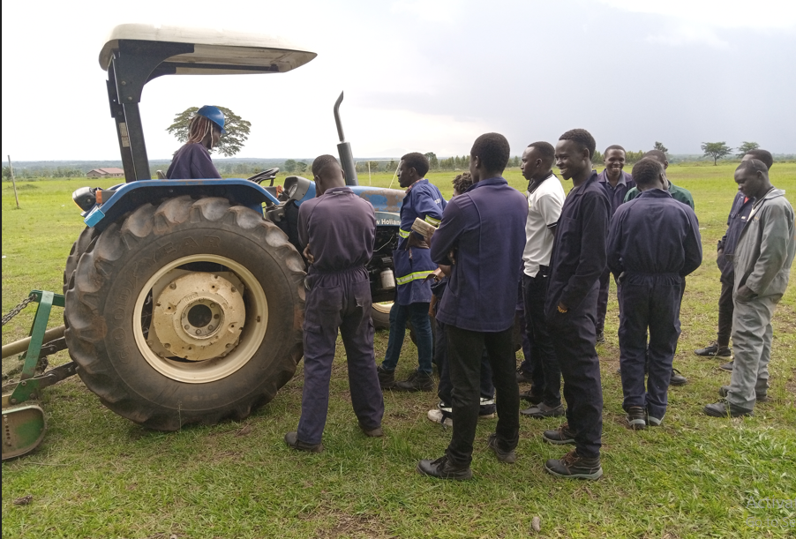

Figure 6: Trainees being introduced to Tractor Driving

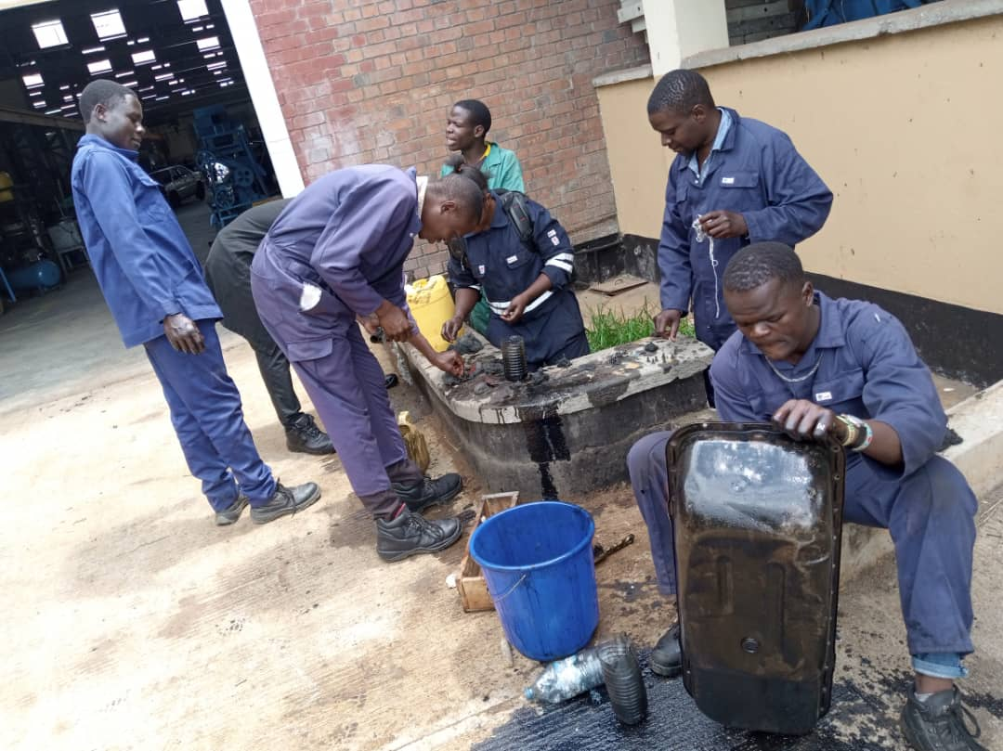
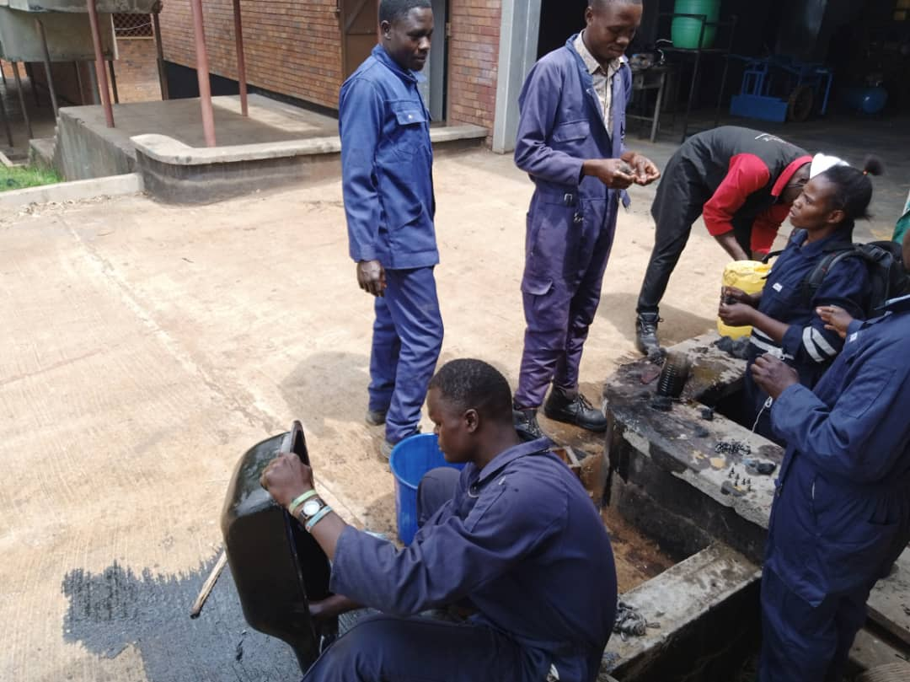

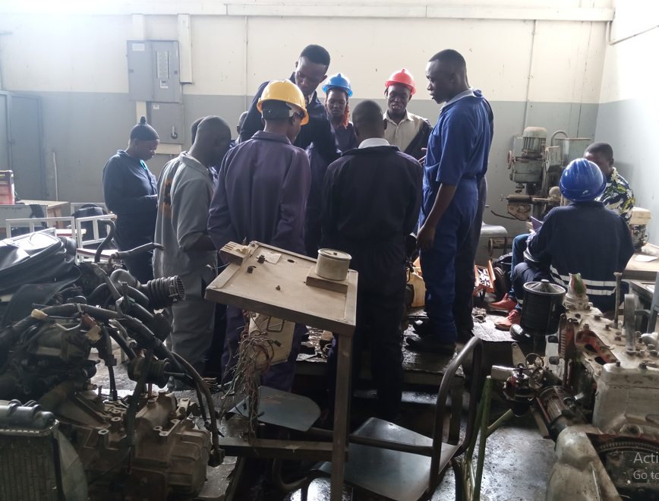
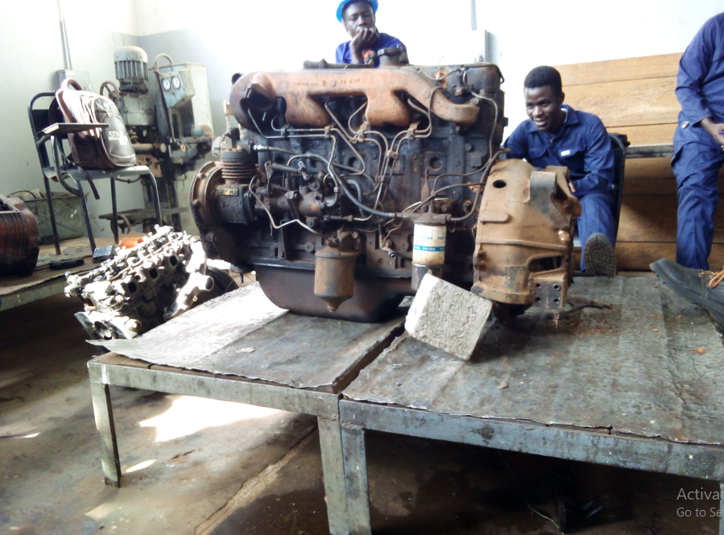

Figure 7: Students overhauling the Engine

List of students that successfully completed the training in CAM
Table 7: Students that successfully completed the training in CAM
 | Name | Gender | Status | District | Certificate Serial Number
1 | Balikowa Regan | M | STANBIC | BUSIA | BU/CAM/001
2 | Bwire Ivan Barasa | M | STANBIC | BUSIA | BU/CAM/002
3 | Bwire Kurumbano | M | STANBIC | BUSIA | BU/CAM/003
4 | Eceru Philip | M | STANBIC | SOROTI | BU/CAM/004
5 | Ekwaro Julius | M | STANBIC | TORORO | BU/CAM/005
6 | Erijat Lawrence | M | STANBIC | TORORO | BU/CAM/006
7 | Ibanda Fahadi | M | STANBIC | KAMULI | BU/CAM/007
8 | Kapere Dan | M | STANBIC | KAMULI | BU/CAM/008
9 | Kawooya Martin | M | SELF | KAMPALA | BU/CAM/009
10 | Kikofu Denis | M | STANBIC | KAMULI | BU/CAM/010
11 | Koyo Samuel Baker | M | STANBIC | MBALE | BU/CAM/011
12 | Magara Benard | M | STANBIC | TORORO | BU/CAM/012
13 | Mangeni Jackson | M | STANBIC | BUSIA | BU/CAM/013
14 | Mangeni Reagan Okello | M | STANBIC | BUSIA | BU/CAM/014
15 | Nabigambo Babra | F | STANBIC | BUSIA | BU/CAM/015
16 | Namuwaya Esther | F | STANBIC | KAMULI | BU/CAM/016
17 | Napete Allan | M | STANBIC | BUSIA | BU/CAM/017
18 | Nekesa Eunice | F | STANBIC | BUSIA | BU/CAM/018
19 | Obuge David Peter | M | STANBIC | PALLISA | BU/CAM/019
20 | Ojono Henry Polycap | M | STANBIC | PALLISA | BU/CAM/020
21 | Okello Noel | M | STANBIC | SOROTI | BU/CAM/021
22 | Olet Allan Innocent | M | STANBIC | TORORO | BU/CAM/022
23 | Othieno Isaac | M | STANBIC | TORORO | BU/CAM/023
24 | Ouma Silas Okumu | M | STANBIC | BUSIA | BU/CAM/024
25 | Owori Moses | M | STANBIC | TORORO | BU/CAM/025
26 | Simali Habert | M | STANBIC | MBALE | BU/CAM/026
27 | Wanyakala Moses | M | STANBIC | MBALE | BU/CAM/027
28 | Zirabamuzale Lawrence | M | STANBIC | BUSIA | BU/CAM/028

List of student(s) that did not complete the training in CAM
Table 8: Students that did not complete the training in CAM
 | Name | Gender | Status | District | No Certificate Awarded
1 | MUWEREZA David Trezeguet | M | SELF | TORORO

General Observation for CAM
- Out of the 29 students that reported to pursue this course, of which 26 are males and 3 are females, 28 successfully completed the training while 1 did not.
- Out of 29 students that reported, 27 were on stanbic while only 2 were on private.

Overall enrolment and completion Summary
Short Course Program | Males | Females | Total no. of students | Stanbic Bank sponsored | Self-Sponsored | Candidates-that completed the course | Candidates that did not complete the course
Certificate in Welding and metal Part fabrication | 21 | 02 | 23 | 23 | 00 | 19 | 04
Certificate in Post-harvest Handling and processing Technologies | 03 | 03 | 06 | 05 | 01 | 06 | 00
Certificate in Brick laying and concrete practice | 03 | 00 | 03 | 03 | 00 | 03 | 00
Certificate in Irrigation technologies and innovations | 08 | 04 | 12 | 12 | 00 | 10 | 02
Certificate in Automotive Repair, Operation and Maintenance | 26 | 03 | 29 | 27 | 02 | 28 | 01
Overall Totals | 61 | 12 | 73 | 70 | 03 | 66 | 07
Completion percentage for Stanbic Bank sponsored students | $$64/70=91.4\%$$
Overall Completion Percentage | $$66/73=90.4\%$$
Note: Of the 7 candidates that did not complete the course, 6 were sponsored by Stanbic Bank and only 1 was self-sponsored

CHAPTER THREE: CHALLENGE(S) AND CONCLUSIONS

Challenge(s)
- The funds were generally insufficient, and therefore if more is availed, additional projects in the respective sections could be worked on in the view of diversifying the training and the overall product output.

Conclusion
- Generally the training was a success. Being the first cohort, we thank Stanbic bank for sponsoring 96% of the students, and we would like to request our sponsors to continue with more of the same even for the subsequent cohorts.

